 | Sanjivani Rural Educational Society’s SANJIVANI COLLEGE OF ENGINEERING  (An Autonomous Institution)  Kopargaon – 423 603, Maharashtra. | ACAD-F-15 K
Academic Year: 2025-26 | CIA ACTIVITY REPORT | Revision: 00 Dated :
Department: Information Technology | Information Technology Engineering | Date of Preparation:  19-04-2026
Course Code & Name: | PCIT208: Software Engineering Modeling and Design | Year /Sem : Second Year Sem II

Activity Title: Learning Management System

Submitted by:

Roll No. | PRN No. | Names
75 | 0124UITF1075 | Jadhav Supriya Dadasaheb
76 | 0124UITM1076 | Nagthane Viresh Sunil
77 | 0124UITM1077 | Sinare Manav Ravindra
78 | 0124UITM1078 | Bohat Swayam Manoj

Prof. S. N. Gunjal Dr. M. A. Jawale
Coordinator Head of IT

Abstract

The Learning Management System (LMS) is a web-based application designed to automate and streamline the educational process in academic institutions. It provides a centralized platform for administrators, teachers, and students to manage courses, assignments, examinations, and communication effectively.
This project aims to overcome the limitations of traditional manual systems by offering features such as user authentication, course management, online quizzes, grade tracking, and resource sharing. The system is built using modern technologies like HTML/CSS/JavaScript for the frontend, PHP/Node.js for backend, and MySQL for the database. It ensures secure access, scalability, and user-friendly interfaces. The proposed LMS enhances learning efficiency, reduces paperwork, and supports remote education, making it ideal for colleges and universities.
Keywords: Learning Management System, E-Learning, UML, DFD, Online Education

INDEX
Sr. No. | Topic | Page no.
 | Abstract | 2
 | Project Definition | 4
 | Introduction | 5
 | Scope of the Project | 6
 | Objectives of the Project | 7
 | Literature Review / Background Study | 8
 | System Analysis  7.1 Existing System  7.2 Problems in Existing System  7.3 Proposed System | 9
 | Software Requirements Specification (SRS)  8.1 Functional Requirements  8.2 Non-Functional Requirements  8.3 Use Case Diagram  8.4 Use Case Description | 10
 | System Design  9.1 UML Diagrams  - Class Diagram  - Sequence Diagram  - Activity Diagram  - Sate chart Diagram  - Collaboration Diagram  - Component Diagram  - Deployment Diagram | 12
 | Data Flow Diagram (DFD) | 19
 | Control Flow Diagram (CFD) | 20
 | Conclusion | 21
 | References | 22

CHAPTER 1

Project Definition

The project involves the development of a comprehensive Learning Management System (LMS) that facilitates digital learning and administrative tasks. It serves as a virtual classroom where:
- Administrators manage users, courses, and system settings.
- Teachers upload study materials, create assignments, conduct quizzes, and evaluate performance.
- Students access courses, submit assignments, take tests, and track their progress.
The system automates processes like enrollment, grading, and reporting, replacing inefficient manual methods. It supports multiple user roles with appropriate permissions and ensures data security and accessibility from anywhere with an internet connection.

CHAPTER 2

Introduction
In the rapidly evolving digital era, the traditional education system is undergoing significant transformation. Conventional classroom-based teaching methods are facing numerous challenges such as limited infrastructure, time constraints, difficulty in managing large student groups, lack of personalized learning, and restricted access to educational resources. The situation became even more critical during the COVID-19 pandemic, which highlighted the urgent need for robust digital platforms to ensure uninterrupted education.
A Learning Management System (LMS) is a software application designed to address these challenges by providing a centralized, web-based platform for managing, delivering, and tracking educational content and activities. It acts as a virtual classroom that facilitates interaction between students, teachers, and administrators from anywhere and at any time.
Today, LMS platforms have become an essential part of modern education systems worldwide. Popular global solutions such as Moodle, Canvas, Blackboard, and Google Classroom have successfully demonstrated the effectiveness of digital learning environments. However, many of these systems are either too expensive for small to medium institutions or overly complex to implement and maintain in the Indian educational context.
This project aims to develop a customized Learning Management System (LMS) specifically tailored for engineering colleges and educational institutions in India. The system focuses on key requirements such as affordability, simplicity, user-friendliness, and compatibility with local academic processes. It supports multiple user roles (Admin, Teacher, and Student) and provides essential features including course management, online assignments, quizzes, grade tracking, resource sharing, and communication tools.
The proposed LMS will not only reduce the administrative workload of teachers but also enhance student engagement, promote self-paced learning, and enable institutions to maintain proper academic records in a systematic and paperless manner. This project is a step towards bridging the gap between traditional education and modern technology-driven learning.

CHAPTER 3

Scope of the Project
In Scope:
- User registration and role-based authentication (Admin, Teacher, Student).
- Course creation, enrollment, and content upload (documents, videos, PDFs).
- Assignment submission, online quizzes/exams with auto-grading.
- Grade management and progress tracking.
- Discussion forums and messaging.
- Reporting and analytics for performance.

Out of Scope:
- Advanced AI-based personalized learning paths (future enhancement).
- Mobile app development (web-responsive only).
- Integration with payment gateways or biometric attendance.
- Large-scale video streaming server.
- The system will be developed as a web application deployable on local servers or cloud.

CHAPTER 4

Objectives of the Project

- To provide a user-friendly interface for efficient courses and user management.
- To automate assignment, examination, and grading processes.
- To enable real-time communication between teachers and students.
- To generate insightful reports on student performance.
- To ensure data security and role-based access control.
- To support scalable deployment for small to medium institutions.

.

CHAPTER 5

Literature Review / Background Study
Existing systems like Moodle (open source) offer robust features but can be complex to customize. Commercial solutions like Canvas provide excellent analytics but are costly.
Literature highlights key benefits: improved student engagement through gamification, progress tracking via learning analytics, and flexibility in content delivery. Studies show challenges in adoption, such as digital literacy gaps and infrastructure issues in rural areas.
This project draws inspiration from open-source models while simplifying features for quicker implementation and lower maintenance costs.

CHAPTER 6

System Analysis
- Existing System
Most institutions rely on manual processes: physical attendance registers, paper-based assignments, email communication, and spreadsheet-based grading. Some use basic tools like Google Classroom or WhatsApp groups.

- 7.2 Problems in Existing System
- Time-consuming manual grading and record-keeping.
- Difficulty in tracking student progress centrally.
- Limited accessibility for remote students.
- Risk of data loss and lack of version control for materials.
- Poor communication and collaboration features.

- 7.3 Proposed System
The proposed LMS overcomes these issues with a centralized, digital platform offering automation, real-time updates, and comprehensive reporting. It is more efficient, secure, and user centric.

CHAPTER 7

Software Requirements Specification (SRS)

- Functional Requirements
- FR 1: User Management: Register, login, profile management.
- FR 2: Course Management: Create/edit courses, upload resources.
- FR 3: Assignment & Quiz: Post assignments, conduct MCQ/descriptive tests.
- FR 4: Grading: Auto and manual grading with feedback.
- FR 5: Forum & Chat: Discussion boards and notifications.

- Non-Functional Requirements
- NFR 1: Performance: Page load < 3 seconds.
- NFR 2: Security: Password hashing, session management, role-based access.
- NFR 3: Usability: Responsive design, intuitive UI.
- NFR 4: Reliability: Backup support and error handling.
- NFR 5: Scalability: Support up to 1000 concurrent users.

- Use Case Diagram
Actors – Admin, Teacher, Student.
Use Cases: Login, Manage Course, Upload Material, Submit Assignment, Take Quiz, View Grades, Generate Report.

- Use Case Description
Example: Take Quiz
- Actor: Student
- Precondition: Enrolled in course.
- Flow: Select quiz → Attempt questions → Submit → View score.
- Postcondition: Score updated in database.

- Use Case Diagram:

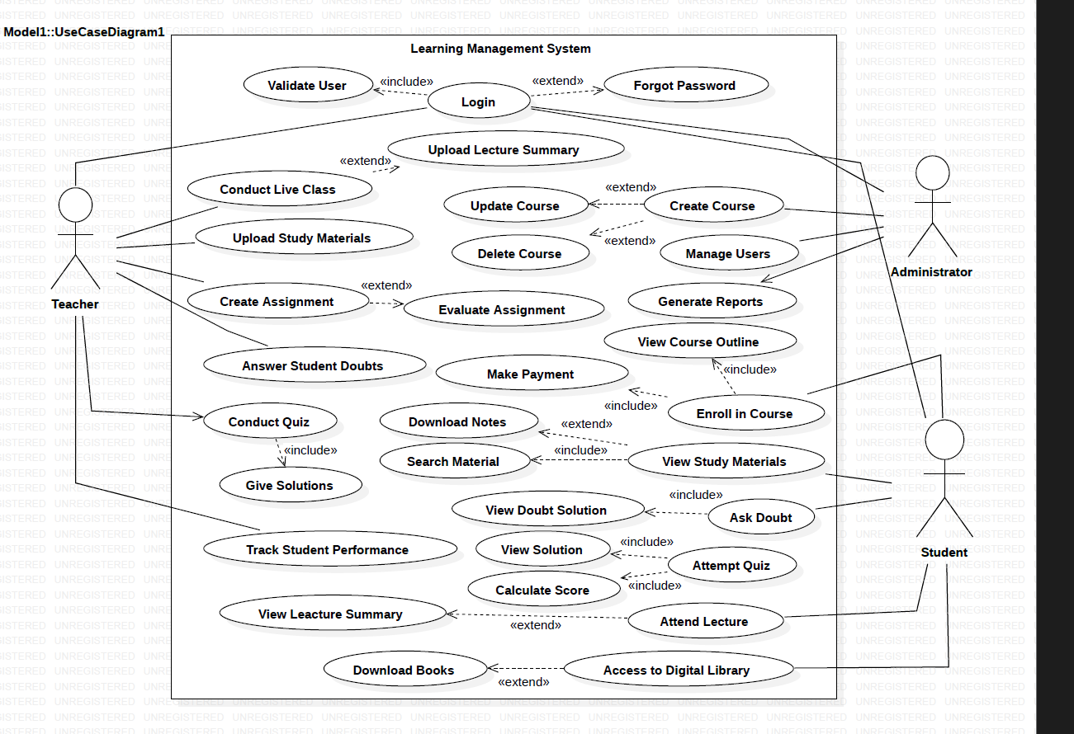

CHAPTER 8

System Design

- UML Diagrams
- Class Diagram: Includes classes like User (with subclasses Admin, Teacher, Student), Course, Assignment, Quiz etc.

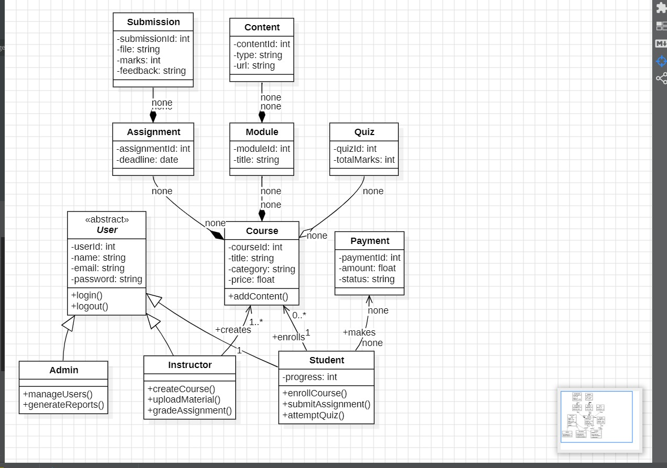

- Sequence Diagram:
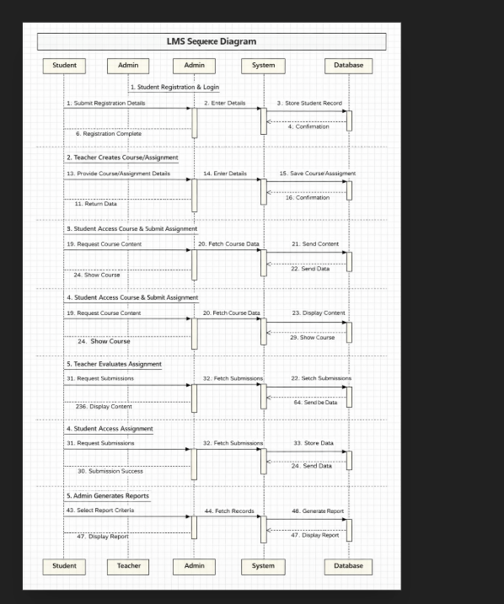

- Activity Diagram:
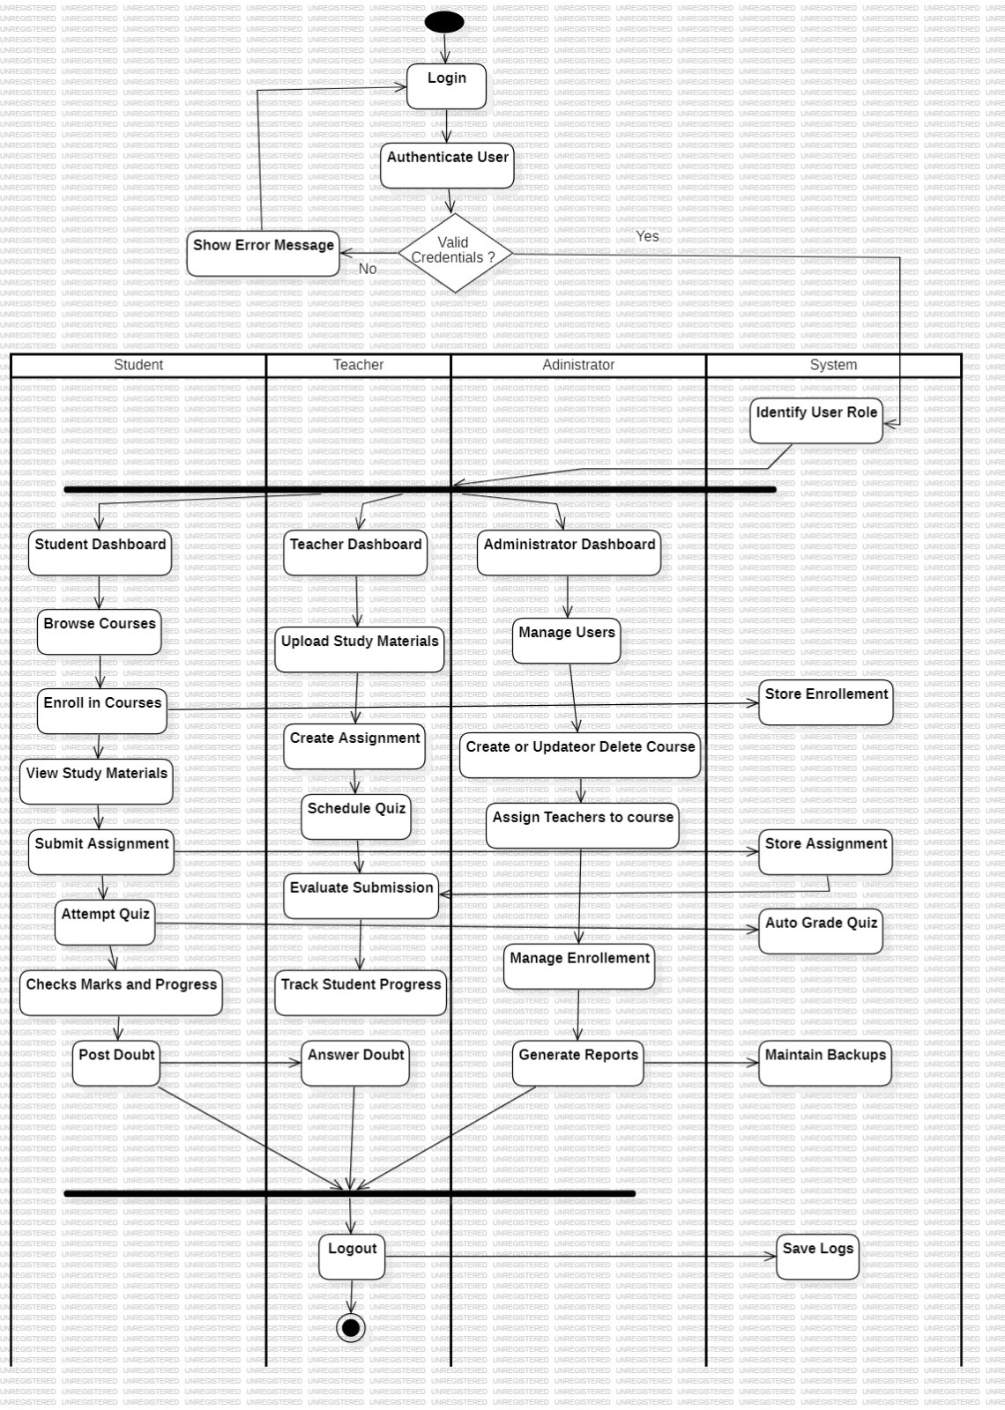

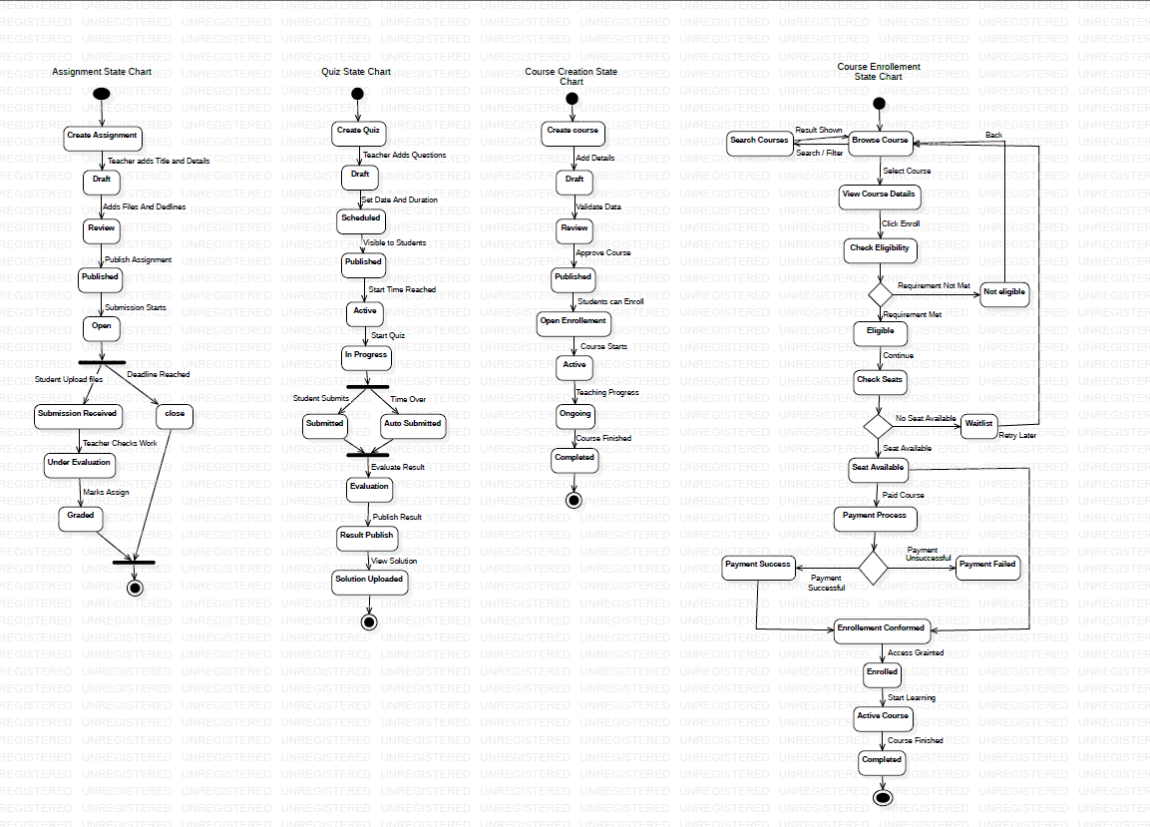
- State Chart Diagram:

- Collaboration Diagram:

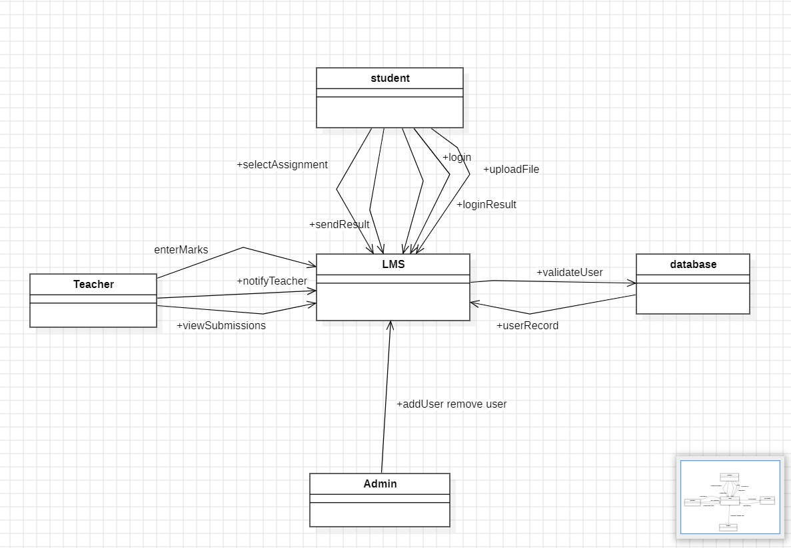

- Component Diagram:
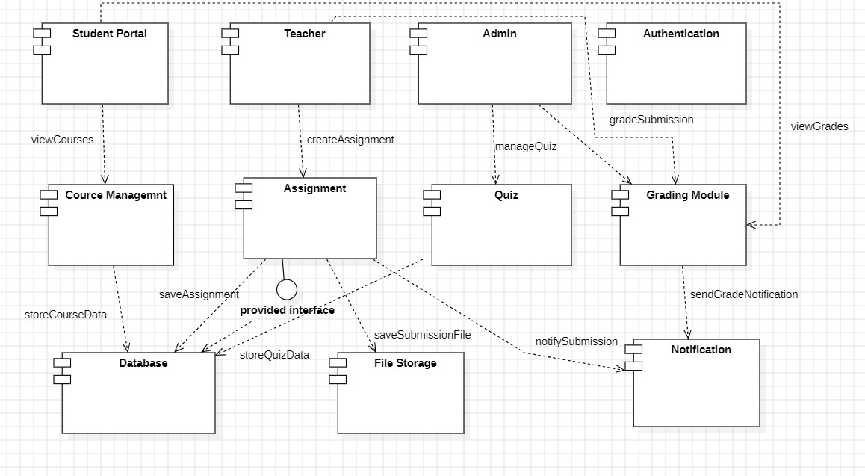

- Deployment Diagram:

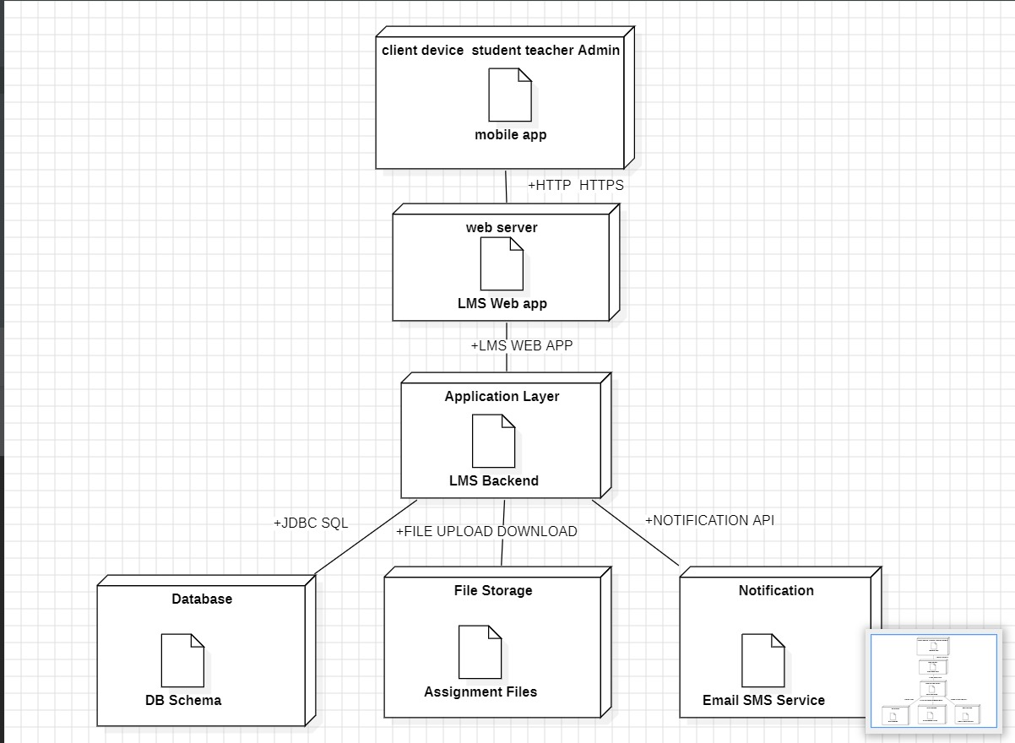

CHAPTER 9

Data Flow Diagram (DFD)
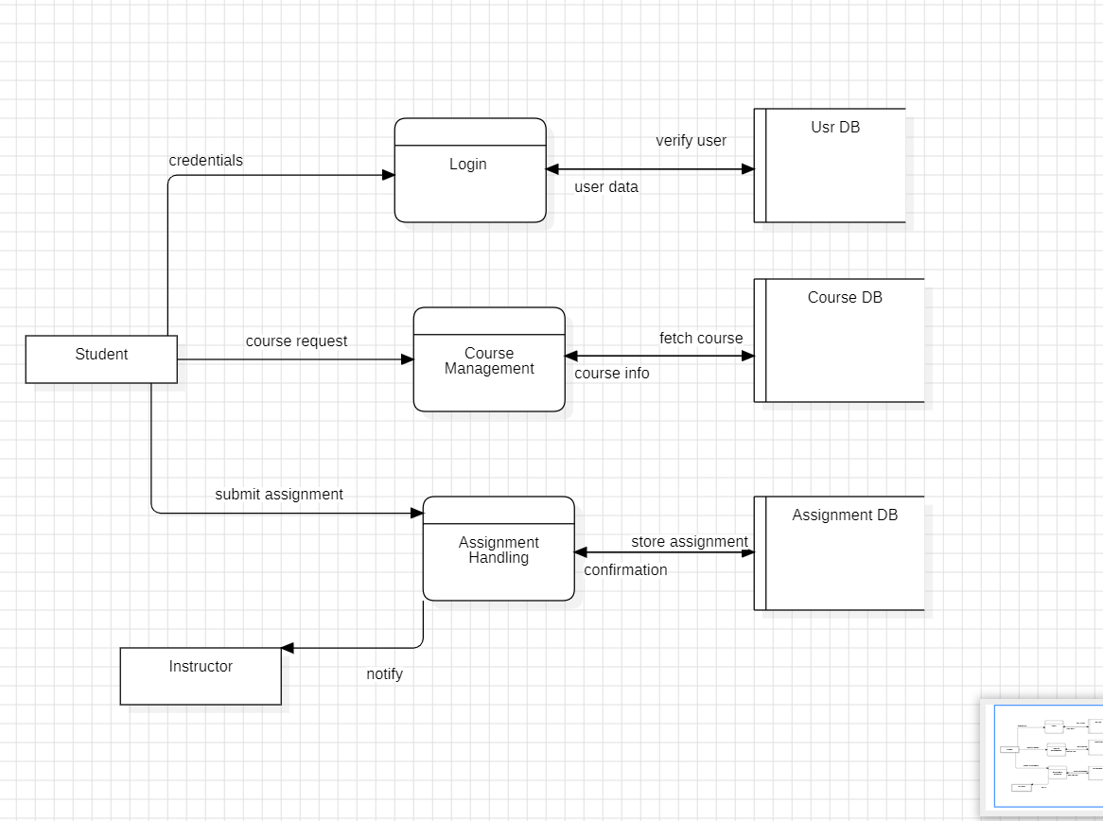

CHAPTER 10

Control Flow Diagram (CFD):
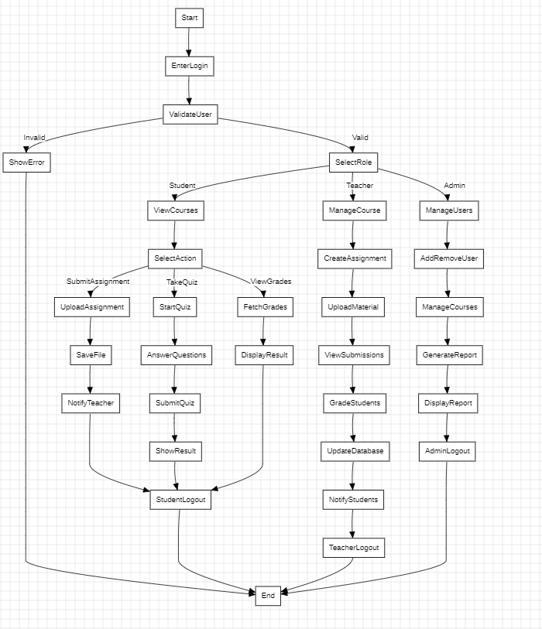

CHAPTER 11

Conclusion

The Learning Management System (LMS) developed during this project is a comprehensive web-based platform that successfully transforms traditional manual academic processes into a modern, efficient, and user-friendly digital system. It provides a centralized environment where administrators, teachers, and students can seamlessly manage courses, assignments, quizzes, grades, and communication.
The system effectively overcomes the major limitations of the existing manual system such as paperwork, time consumption, data loss, and lack of real-time tracking. Key features like role-based access control, online examination, automated grading, file sharing, and notification services make it highly practical for engineering colleges and educational institutions.
This project has not only fulfilled the functional and non-functional requirements but also delivered a scalable, secure, and maintainable solution. The use of UML diagrams, DFD, and proper software engineering principles during the development phase ensured a well-structured and professional outcome.

CHAPTER 12

References

  - Greek for Geeks: -
- https://www.geeksforgeeks.org/systemdesign/online-learning-management-system-srs/

  - IEEE
- https://ieeexplore.ieee.org/document/5492522

  - E-Learning Management System UML Diagram
- https://www.freeprojectz.com/uml-diagram/e-learning-management-system-uml-diagram

